**Design Masterclass Module**

Recorded Meeting Minutes on Project Development between

Andreea Mazarianu and Cyclosion Games

**Cyclosion Games Webpage:** [**https://www.cyclosion.com/games.html**](https://www.cyclosion.com/games.html)

**1st February 2020**

**Danny Colclough (Cyclosion Games) & Andreea Mazarianu**

The character concept art was postponed until the completion of all the pick-up assets for the game.

The first deliverables were presented (props): Energy Vials and Upgrade Kit.

The client was satisfied with the presented design sheet featuring variations of possible concepts for the Energy Vials and Upgrade Kit assets. From the presented iterations the client has chosen his preferred versions of the 2 props.

The changes required for the concept designs by the client included:

* Colour change for the Energy Vials to cerulean
* Colour change for the Upgrade Kit to yellow

It has been decided that after the changes were made to the assets these will be exported as individual PNGs with transparent background and uploaded to the project’s shared Dropbox set by the client.

AM requested to know the priority list for the next two pick-ups that she has to prepare for the following week. DC has stated that he will be creating a spread sheet of all the pick-ups that will need to be conceptualized during the project. The document will be including the pick-up’s name, a brief description of what the purpose/ look of it should be.

**5th February 2020**

**Danny Colclough (Cyclosion Games) & Andreea Mazarianu**

DC provided a link to the Google Spreadsheet with the start of the pick-ups list. The prioritized concepts for the following week were established to be for the Charger weapon and Health pick-up. (see image provided below)

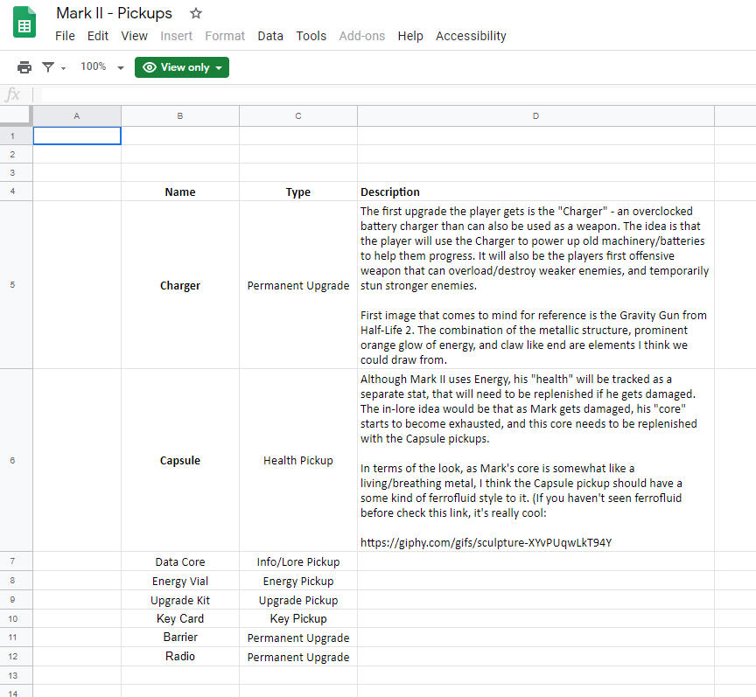

**12th February 2020**

**Danny Colclough (Cyclosion Games) & Andreea Mazarianu**

AM has contacted DC in order to inform and apologize for the possibility of completing the work later than agreed because she was preparing for the Final Project Presentation on 17th February.

The client approved of the newly set deadline and was happy to be informed about the changes in advance.

AM requested that the communication should be changed to email for future updates. DC agreed.

**25th February 2020**

**Danny Colclough (Cyclosion Games) & Andreea Mazarianu**

AM has provided a project update to DC via email (see image below – Zoom In). This included:

* Design sheet for the Charger weapon (presenting variations)
* Design sheet for the Health pick-up
* Comment on how the references provided were used
* Suggestions on how the references provided were modified to fit the game’s IP (maintain consistency – Energy Vials must fit the colour of the Charger weapon since both of them are powered by the same element) and convey the desired message to the player (based on shape psychology)
* Provided extra development tracking details – GitHub. Although the project’s deliverables are uploaded to a shared Dropbox, a link to the project’s Github was provided as backup for the files. Moreover, it includes all meeting minutes, moodboards, design sheets and exported 2D assets that the client may be interested in.

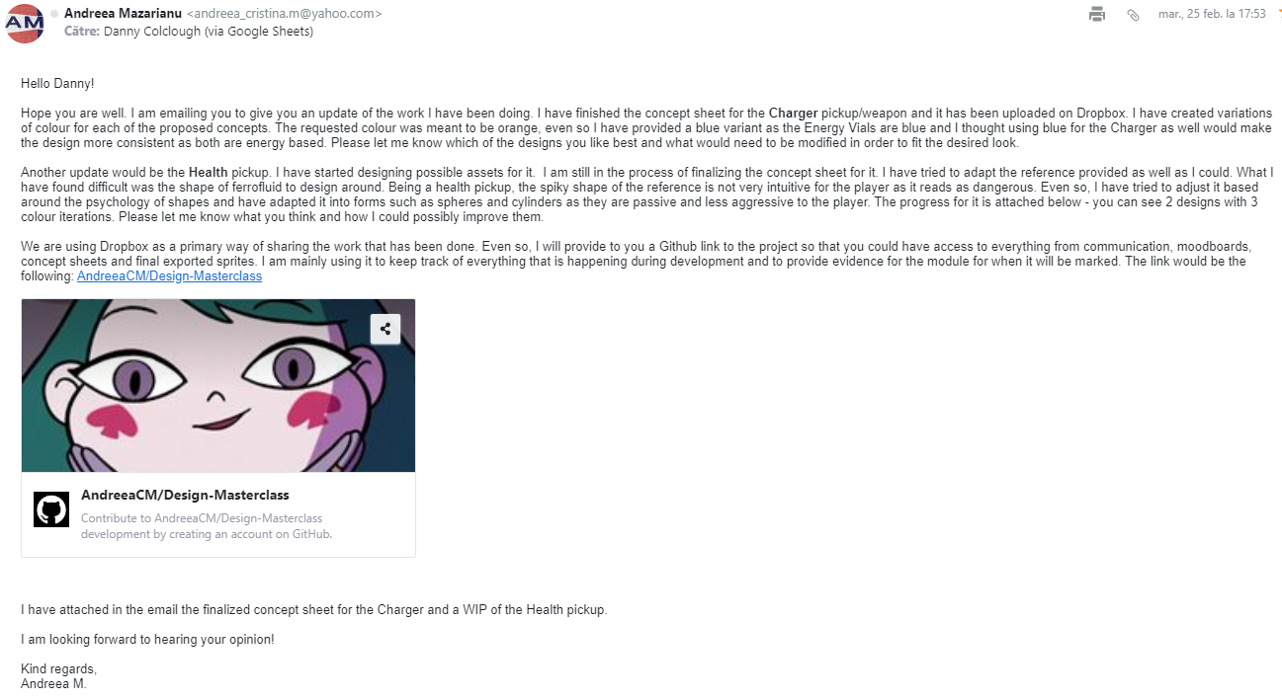

**27th February 2020**

**Danny Colclough (Cyclosion Games) & Andreea Mazarianu**

Reply from DC (image of the response is provided below – Zoom In) underlined the following aspects:

* Pleased with design sheets
* Agreed on the suggestions made on the design adjustments for the Charger weapon and Health pickup
* Chosen the preferred designs for the 2 assets
* Made comments on how they could be improved to fit the requirements of the game and provided a reference image for better understanding of the use of the Charger weapon
* Changes to the Charger weapon refer to the removal of the grip, as it will be a mount on the main character’s forearm.
* Offered to provide additional information on the assets if needed.
* Stated that the Google Spreadsheet will be completed with additional information for the rest of the assets by 1st March.

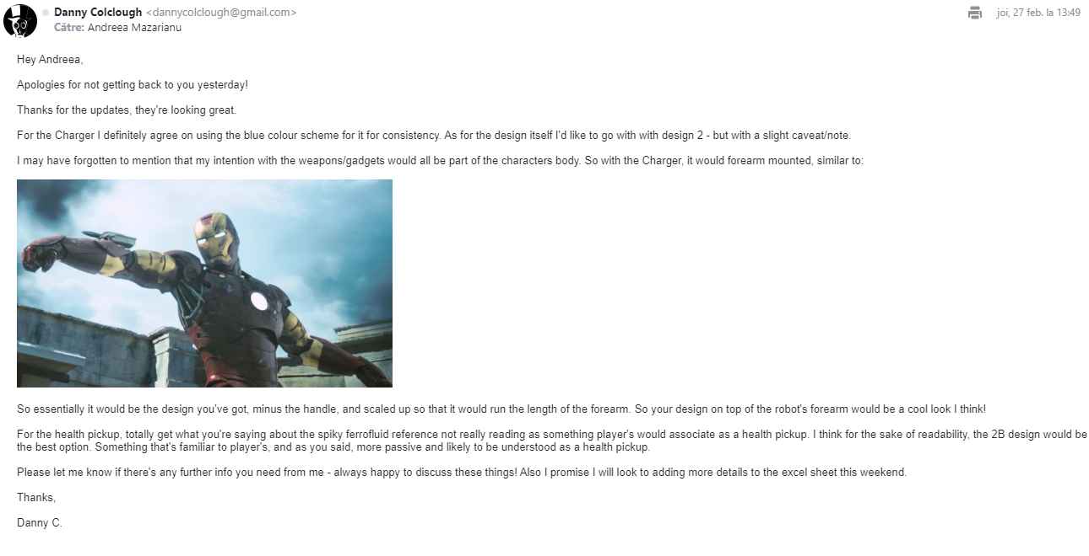

**17th March 2020**

**Danny Colclough (Cyclosion Games) & Andreea Mazarianu**